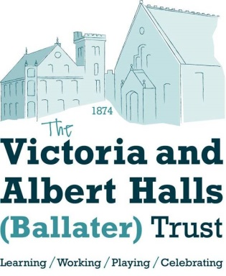

**MEMBERSHIP REGISTRATION FORM**

To: Victoria & Albert Halls (Ballater) Trust

**I wish to become a member of the Registered Charity, Victoria & Albert Halls (Ballater) Trust, subject to the Memorandum and Articles of Association.**

|  |  |  |  |
| --- | --- | --- | --- |
| Signed | …………………………………………. | Date …………………………………… | |
| Name | ………………………………………… | Tel No…………………………………… | |
| Address | ………………………………………… | Email …………………………………… | |
|  | …………………………………………. |  | |
| Other Members of the Household who wish to join and are 16 years of age or over - | | | |
| Signed | …………………………………….. | Signed | …………………………………………… |
| Name | …………………………………….. | Name | …………………………………………… |
| Signed | …………………………………….. | Signed | …………………………………………… |
| Name | …………………………………….. | Name | …………………………………………… |

There is no membership fee.

Please return this form “For the attention of the Trustees, Victoria & Albert Halls (Ballater) Trust” to the address below.

For enquiries or further information call/leave message at 013997 53726.

The information provided on this form is held in compliance with the General Data Protection Regulation 2018 and will be for the sole use of Victoria & Albert Halls (Ballater) Trust as stated in its Data Protection Policy and will not be provided to any third party.

Address: Victoria & Albert Halls (Ballater) Trust, AlbertMemorial hall, Station Square, BALLATER AB35 5QB

E-mail: [membership@victoriaandalberthalls.co.uk](mailto:membership@victoriaandalberthalls.co.uk) Web: [www.victoriaandalberthalls.co.uk](http://www.victoriaandalberthalls.co.uk/)

Scottish Charity Number: SC0 043209